[ Insert official UPAEP logo ]
UPAEP · Decanato de Ingenierías
EVIDENCE — US07-T1
Design the measurement data model
SmartGreenAI: Cilantro Crop

1. Task information
Task ID | US07-T1
User Story | US-07 — Store measurements with sensor IDs and timestamps
Sprint | Sprint 2 (2026-09-21 – 2026-10-09)
Week | Week 1
Responsible | Oscar Abraham Talavera Nava
Peer reviewer | Vicente Rocha Alfaro
Planned / actual hours | 2 h / 2 h
Completed on | September 25, 2026
Status | Done

2. Task description
Create the entity-relationship diagram for devices, sensors and measurements. Measurement fields: id, sensor_id (FK), value, unit, recorded_at (UTC, from the device) and received_at (UTC, from the server).

3. Completion conditions
✓ Condition 1: ER diagram includes devices, sensors and measurements with their relationships.
How it was verified: The ER diagram includes devices, sensors and measurements (plus actuators, which also belong to a device) with their relationships: a device has many sensors, a sensor produces many measurements.
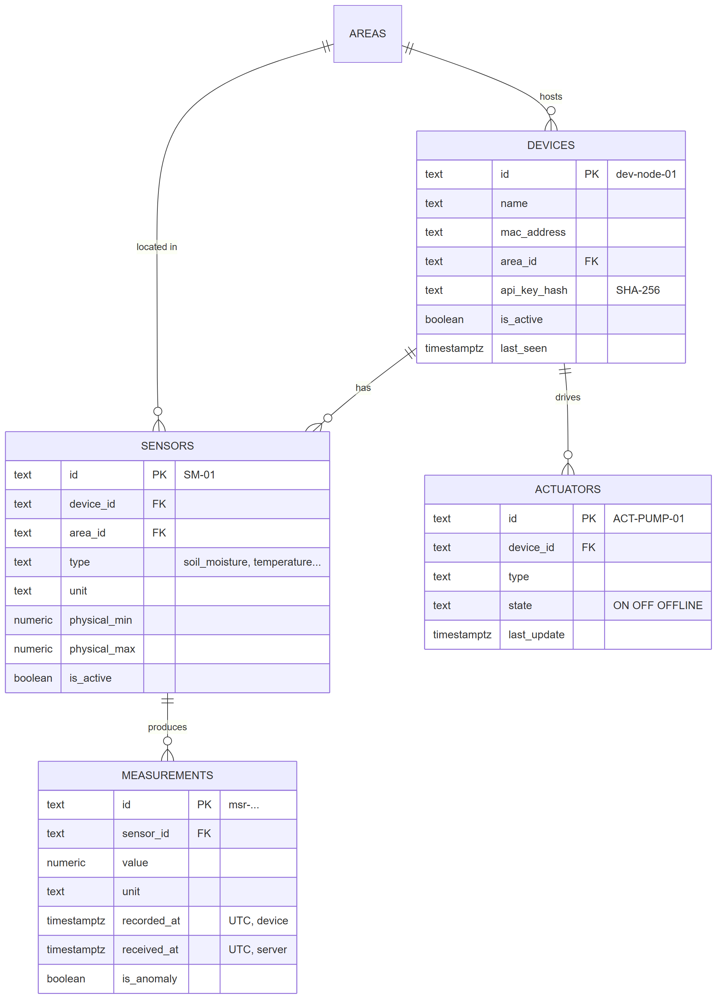
Figure US07-T1-1. Entity-relationship diagram of devices, sensors, actuators and measurements (source: tools/evidence/diagrams/er_devices_sensors_measurements.mmd). (US07-T1_Design_Measurement_Data_Model_1.png)
Foreign keys between devices, sensors and measurements (5 rows; US07-T1_Design_Measurement_Data_Model_4.csv)
table_name | column_name | references_table | references_column
actuators | area_id | areas | id
actuators | device_id | devices | id
measurements | sensor_id | sensors | id
sensors | area_id | areas | id
sensors | device_id | devices | id
SQL: SELECT tc.table_name, kcu.column_name, ccu.table_name AS references_table, ccu.column_name AS references_column FROM information_schema.table_constraints tc JOIN information_schema.key_column_usage kcu ON kcu.constraint_name = tc.constraint_name JOIN information_schema.constraint_column_usage ccu ON ccu.constraint_name = tc.constraint_name WHERE tc.constraint_type = 'FOREIGN KEY' AND tc.table_name IN ('sensors','measurements','actuators') ORDER BY tc.table_name, kcu.column_name
✓ Condition 2: Measurement fields include sensor_id, value, unit, recorded_at and received_at (UTC).
How it was verified: The measurement entity has id, sensor_id (foreign key), value, unit, recorded_at (UTC, from the device) and received_at (UTC, set by the server), as the table created in the database shows. All timestamps are TIMESTAMPTZ and the connection runs with timezone UTC.
Columns of the measurements table as created in the database (8 rows; US07-T1_Design_Measurement_Data_Model_2.csv)
column_name | data_type | is_nullable | column_default
id | text | NO | ('msr-'::text || encode(gen_random_bytes(6), 'hex'::text))
sensor_id | text | NO
value | numeric | NO
unit | text | NO
recorded_at | timestamp with time zone | NO
received_at | timestamp with time zone | NO | now()
device_status | text | NO | 'OK'::text
is_anomaly | boolean | NO | false
SQL: SELECT column_name, data_type, is_nullable, column_default FROM information_schema.columns WHERE table_name = 'measurements' ORDER BY ordinal_position
✓ Condition 3: Diagram reviewed and approved by Carlos and Alexis.
How it was verified: The diagram was reviewed with Carlos (API, US-08) and Alexis (device registry, US-25) in Week 1 and approved (approval record below).
✓ Condition 4: Evidence: ER diagram reviewed with Carlos and Alexis.
How it was verified: ER diagram (Figure 1) reviewed with Carlos and Alexis; the implemented tables match it.

4. Attached files
- US07-T1_Design_Measurement_Data_Model_1.png
- US07-T1_Design_Measurement_Data_Model_2.csv
- US07-T1_Design_Measurement_Data_Model_3.sql
- US07-T1_Design_Measurement_Data_Model_4.csv
- US07-T1_Design_Measurement_Data_Model_5.sql

5. Traceability
Related requirements | FR-06, FR-07, FR-08, FR-20, NFR-05
Implementation | See docs/TRACEABILITY.md
Verification | See docs/TRACEABILITY.md

6. Sign-off
Role | Name | Date | Signature
Responsible | Oscar Abraham Talavera Nava | September 25, 2026
Peer reviewer | Vicente Rocha Alfaro | September 25, 2026
Product Owner acceptance | Alexis Enrique Valle Parra | September 25, 2026
Approval record: Daily Meeting 2 of Sprint 2 (Monday, September 28, 2026): "Review of the Week 1 milestone: US-01-C closed, API specification (US08-T1) shared on Wednesday, ER diagram and payload format approved." Decision: the firmware obtains UTC by NTP and sends recorded_at in ISO 8601; the server also stores received_at.

